AWS Event Driven Architecture
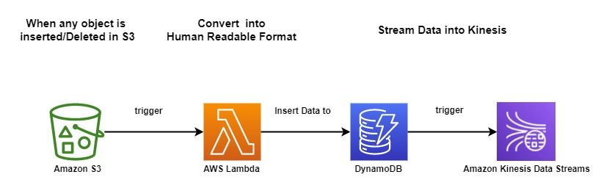
What is AWS Event Driven Architecture ?
- AWS Event-Driven Architecture is an approach that utilizes Amazon Web Services to build scalable and decoupled applications.
- It relies on events as the primary means of communication between components.
- The architecture includes event sources that generate events, an event bus for routing events, rules to filter and route events, and targets for actions triggered by events.
- Event Driven Architecture offers benefits such as scalability, loose coupling, flexibility, and real-time processing.
Prerequisites
- AWS Account GitHub Repo:- https://github.com/sampathshivakumar/Event-Driven-Architecture
Lets start Builing Event Driven Architecture
Create S3 Bucket
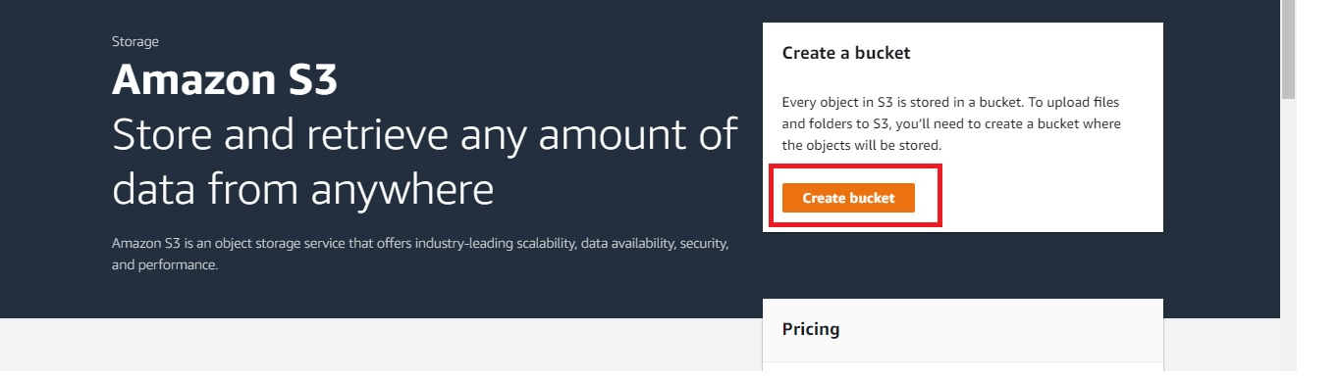
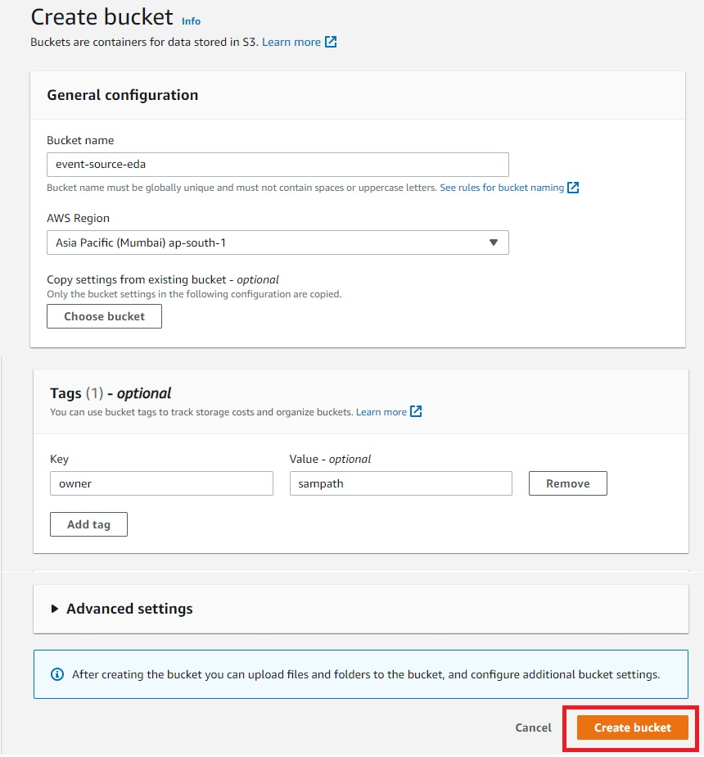
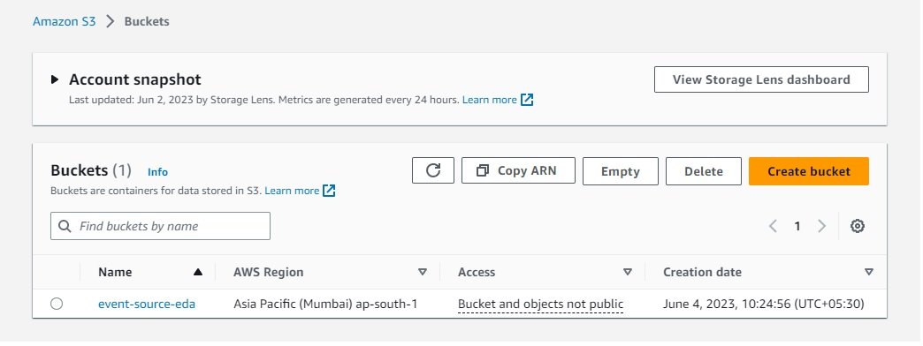
Now let's create Lambda
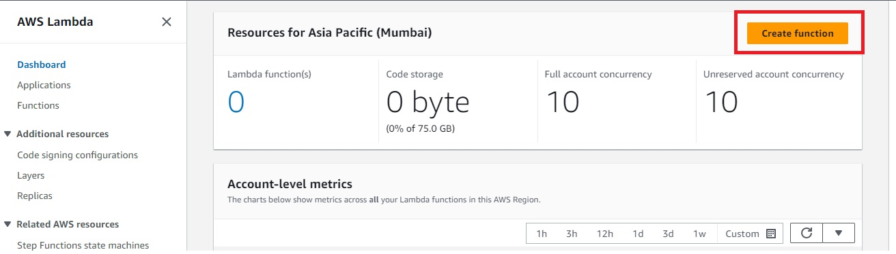
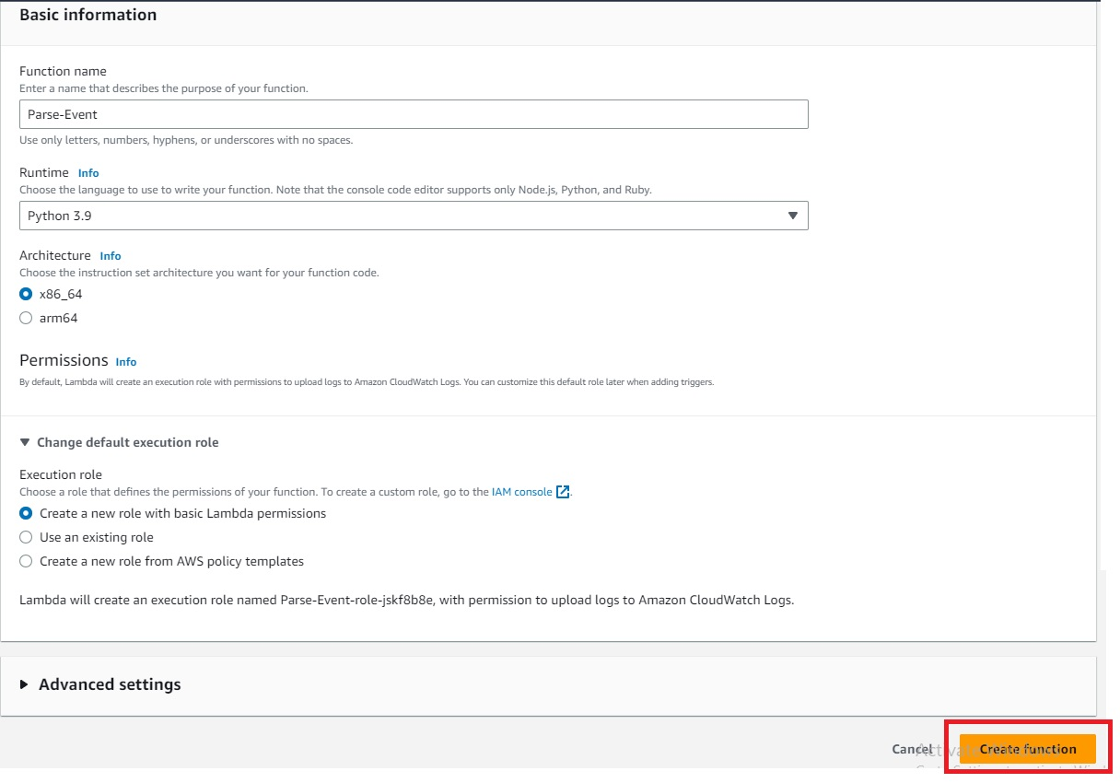
Set the Time out for Lambda to 5 mins
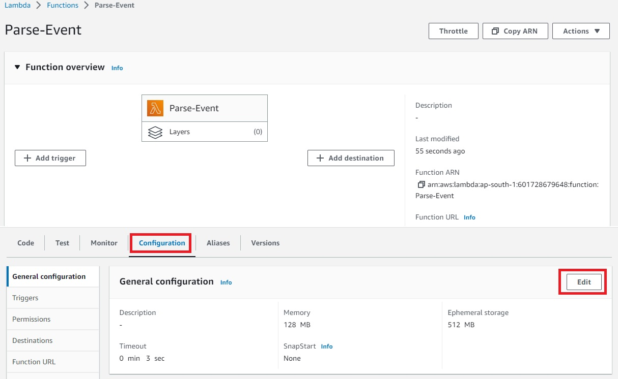
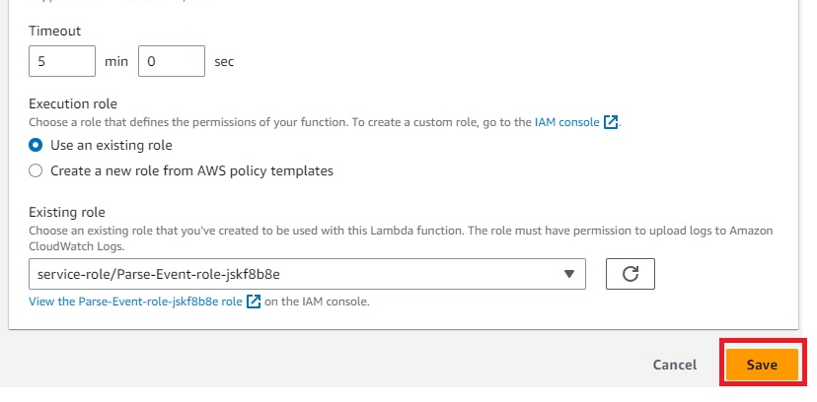
Time out has been modified
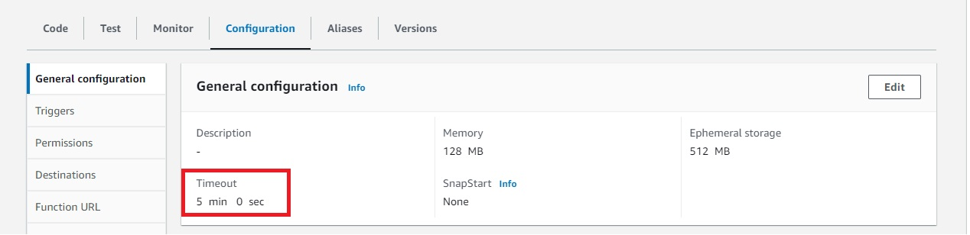
Add DynamoDB full access to Lambda
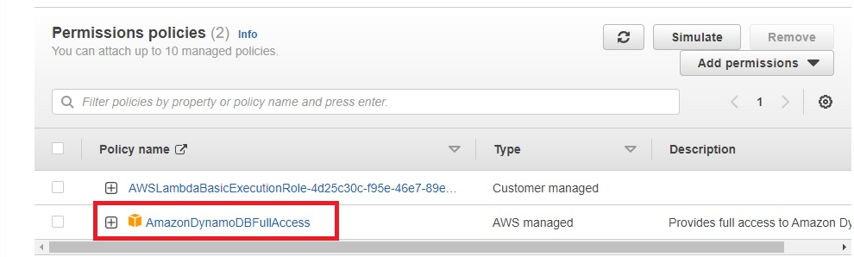
Add print events in Lamda code
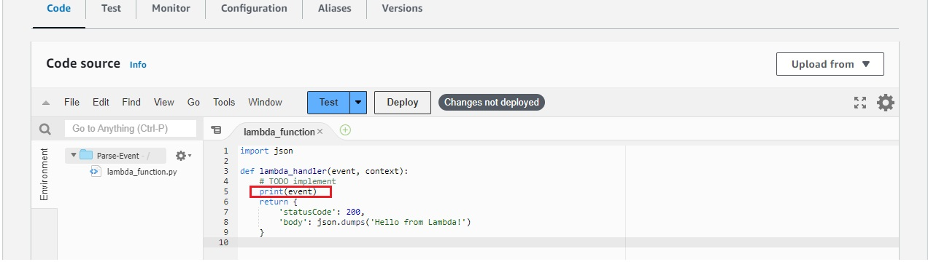
As of now there are no cloudwatch logs, as Lambda is not triggered
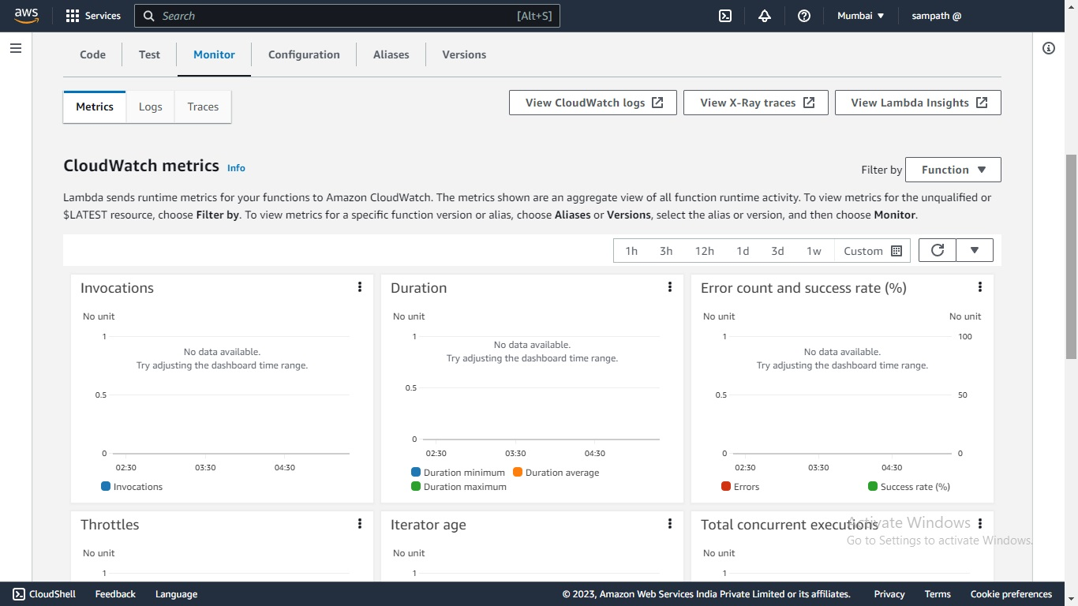
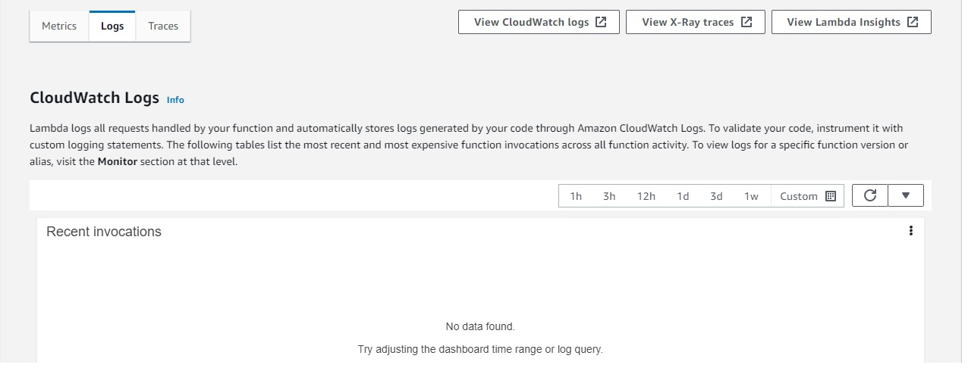
Now lets Integrate S3 Bucket to Lambda
Go to Properties tab inside your bucket and Create event notification
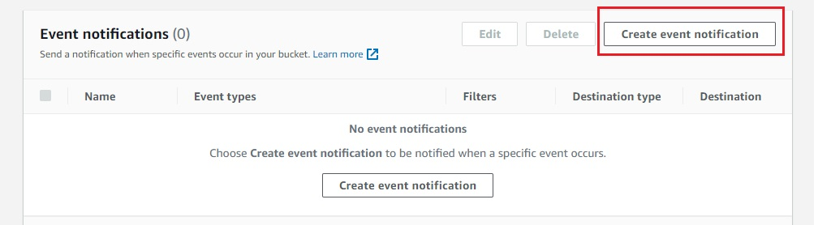
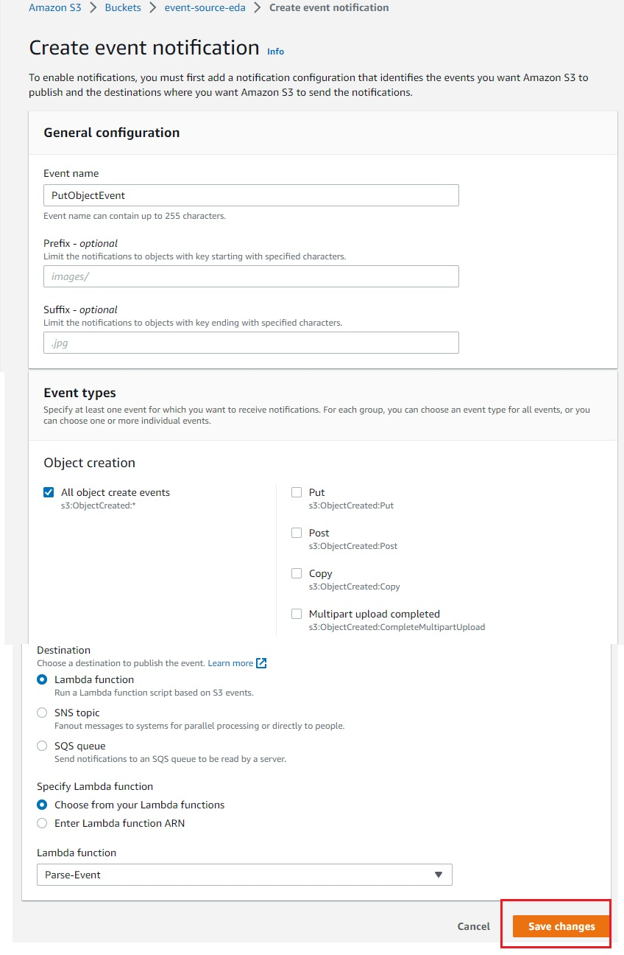
You should see this
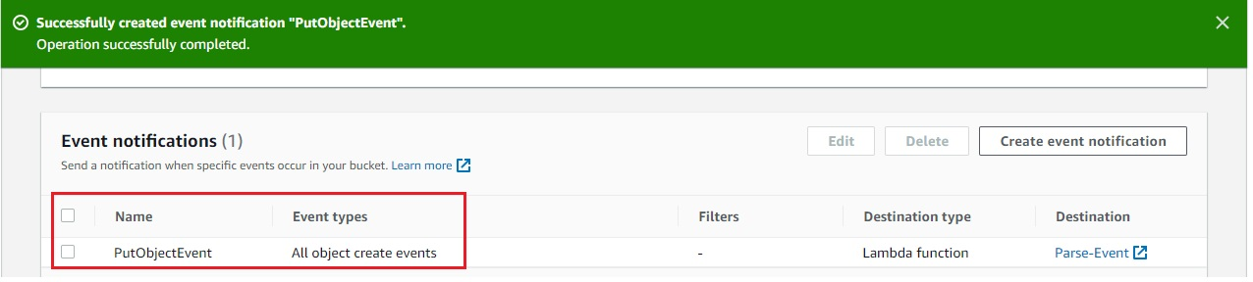
Now what it means is when ever any object is inserted into S3 Bucket it will trigger Lambda function
Lets inssert a simple sample.json file into S3 Bucket
{
"Name" : "SampathShivaKumar",
"Role" : "DevOps",
"Email": "sampathshivakumar@gmail.com"
}
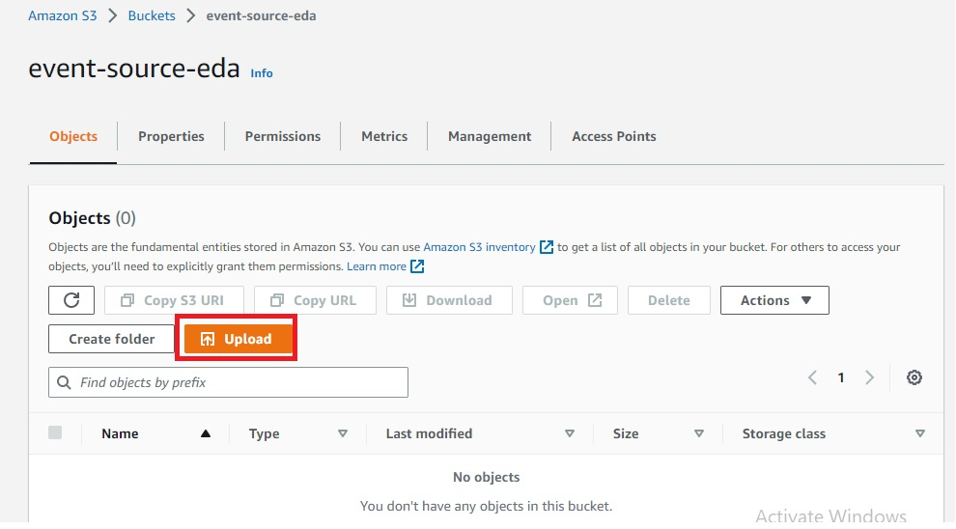
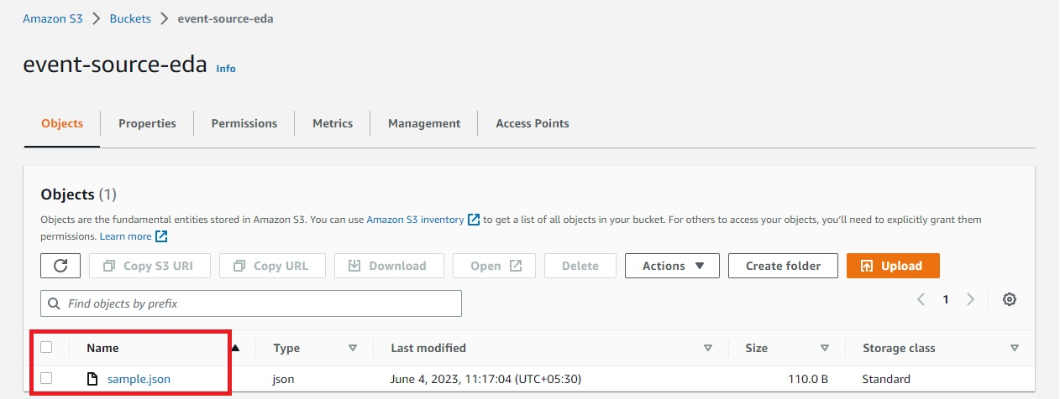
Now S3 Bucket should have triggered Lambda Function, Check CloudWatchlogs to verify
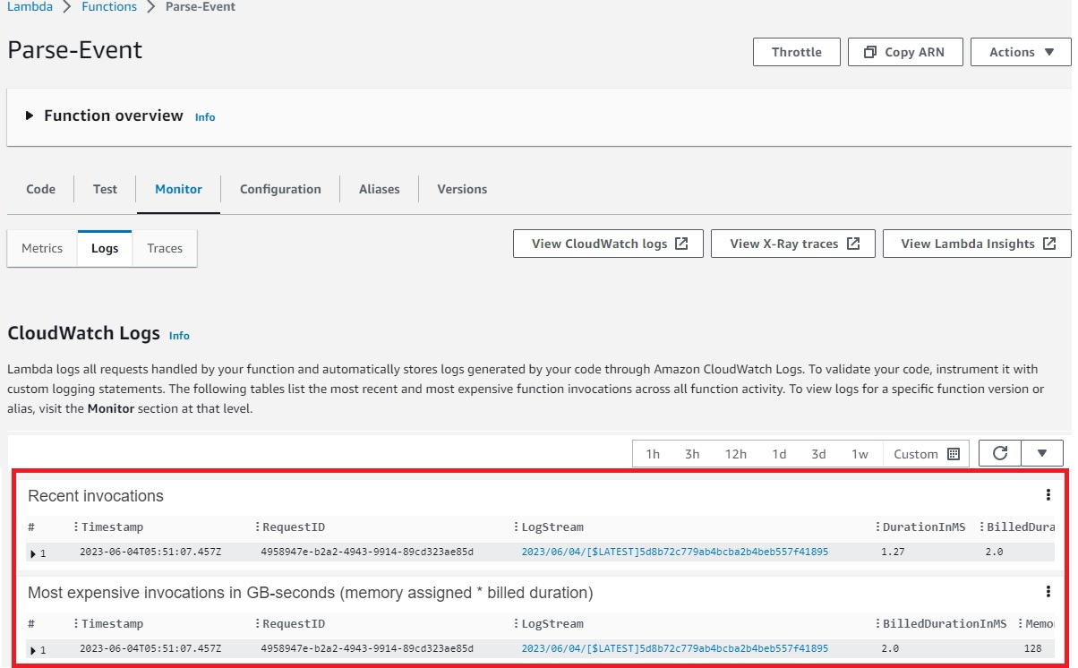
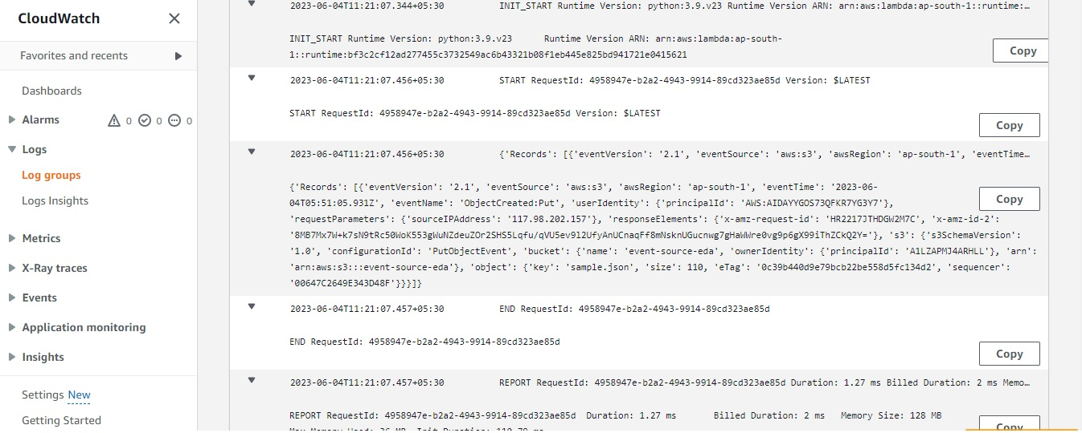
Now we need Lambda to extract content of files and insert it to DynamoDB table
Let's create a DynamoDB Table
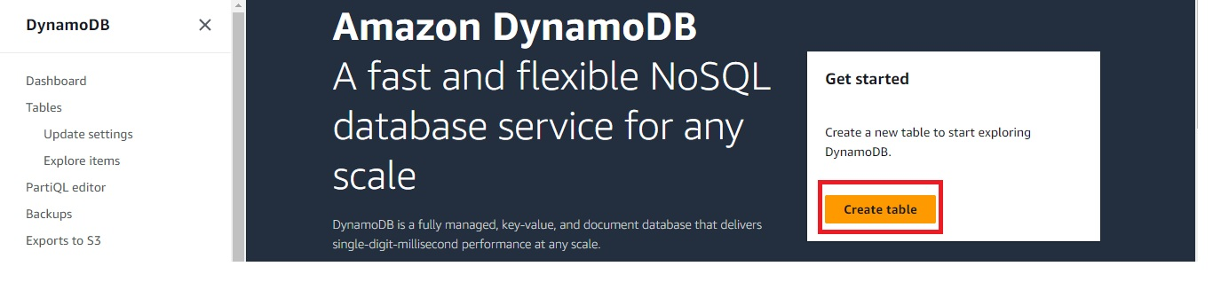
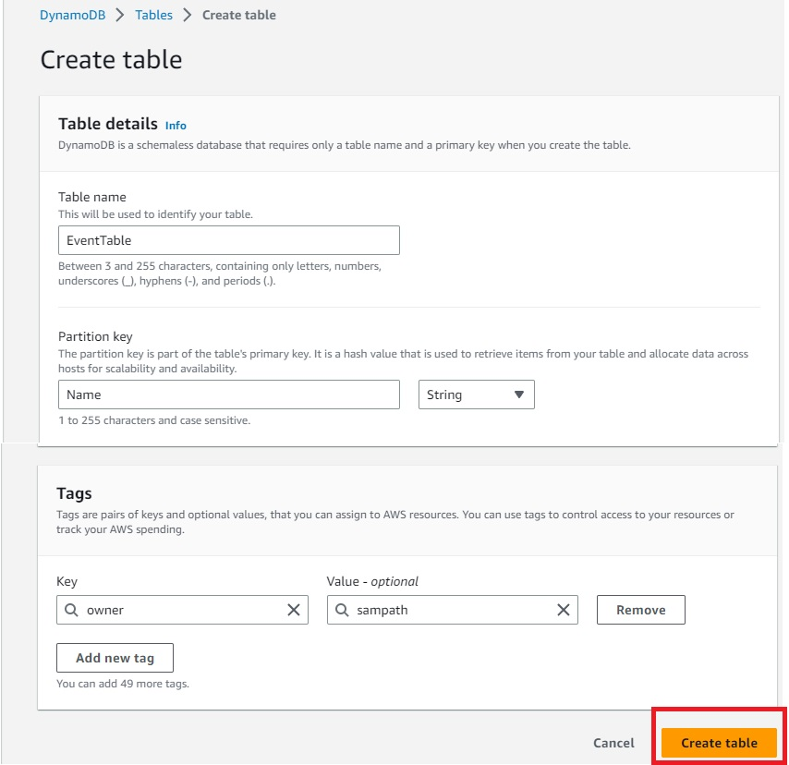
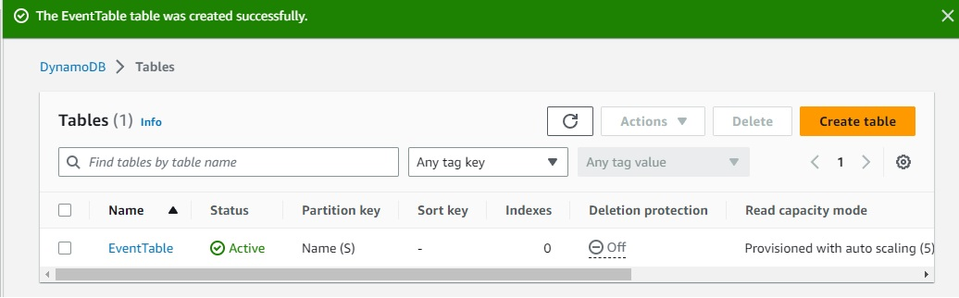
Now we have to code Lambda so that it can extract the content of file and send data to DynamoDB
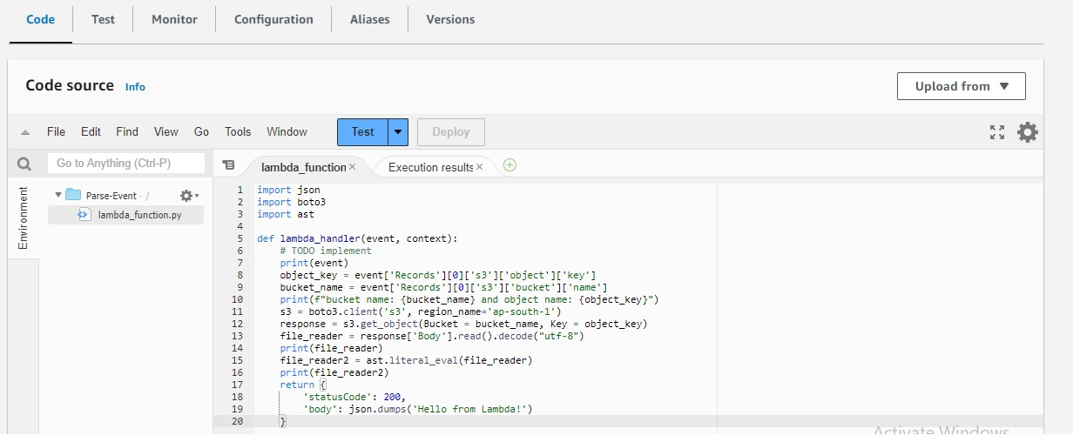
Now to trigger Lambda upload file again to S3 Bucket
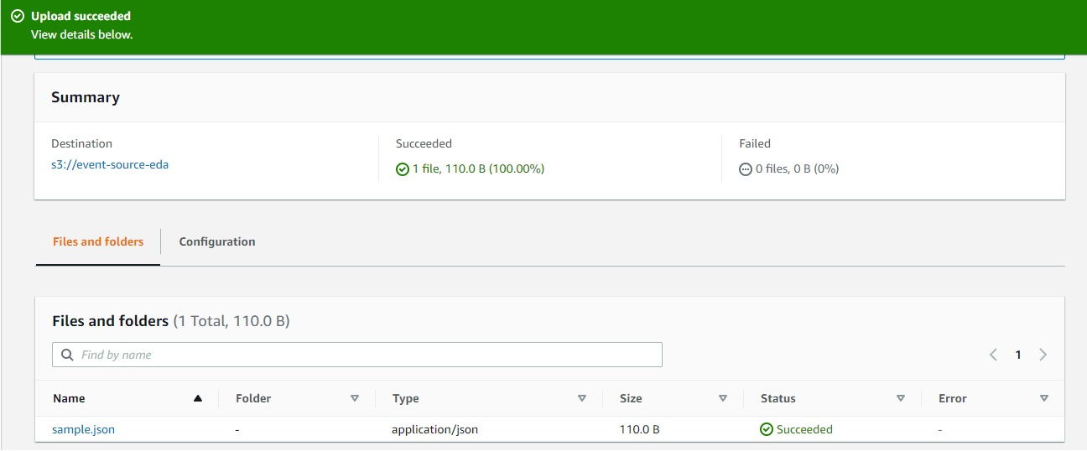
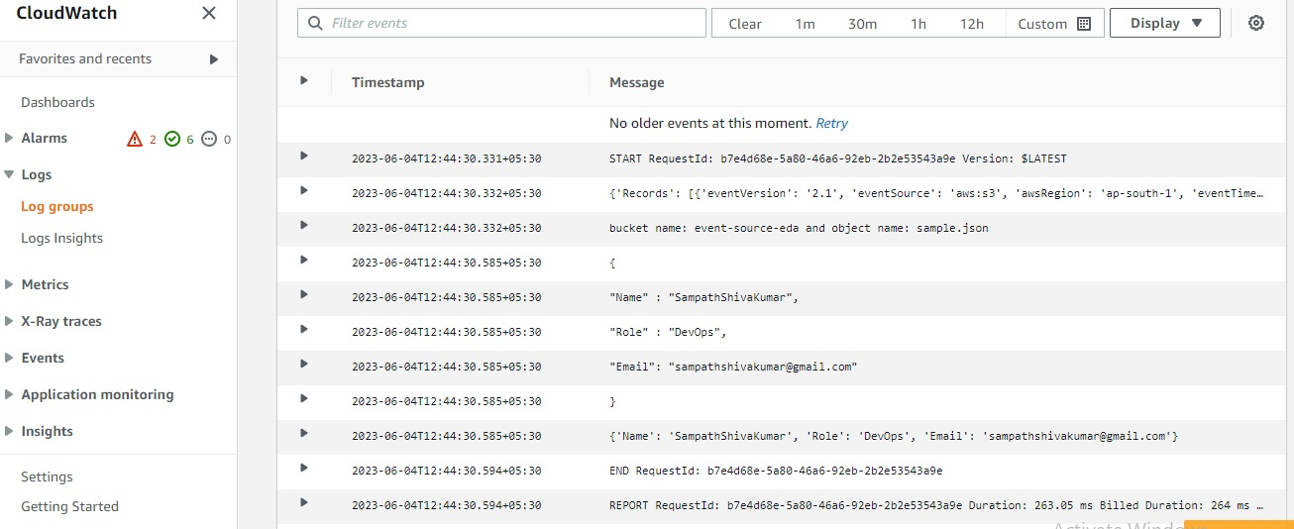
Lambda is working fine, now we have to add these record into DynamoDB table
Modify the code for Lambda to insert records into DynamoDB Table
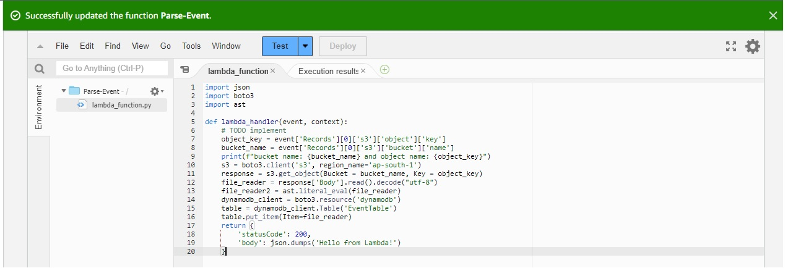
As of now you can see no data inside DynamoDB Table
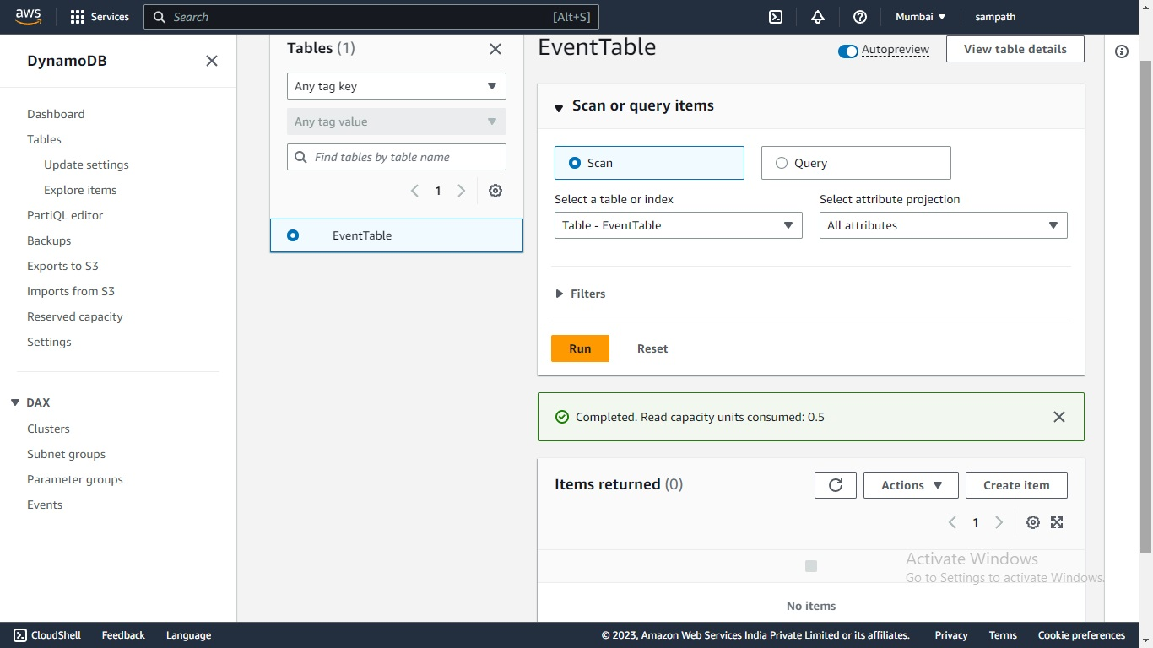
Now to trigger Lambda upload file again to S3 Bucket
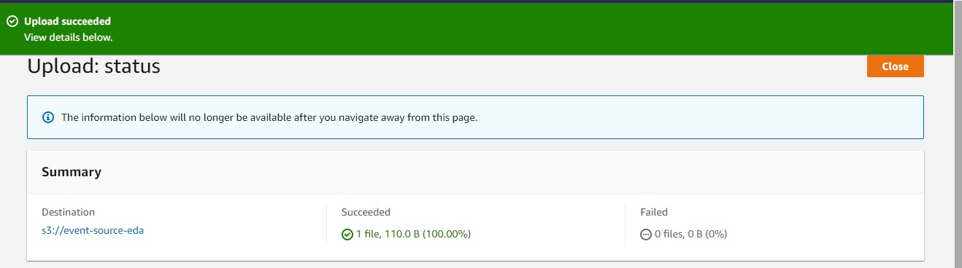
Now Lets see DynamoDB table again,By now s3 should trriger lambda function and lambda should insert data into DynamoDB table
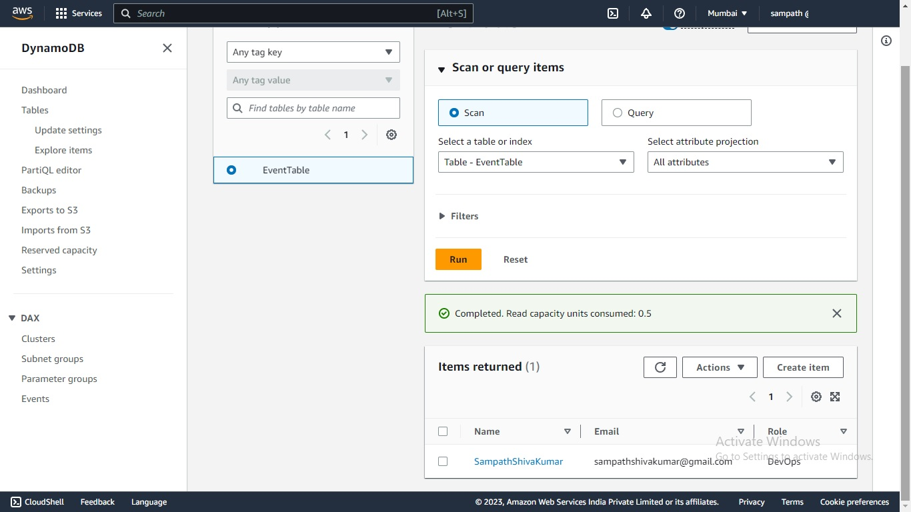
AWS Event Driven Architecture is successfully built and is functioning as expected
Note: Code is taken from https://github.com/nspacer/eventDrivenArchitectureP1 , i have not written the code myself.
Thank you for reading this post! I hope you found it helpful. If you have any feedback or questions,Please connect with me on LinkedIn at https://www.linkedin.com/in/sampathsivakumar-boddeti-1666b810b/. Your feedback is valuable to me. Thank you!

